Credit Card Fraud Detection
Model Evaluation & Business Insights Report

1. Project Summary
This report summarizes the development and evaluation of a machine learning system for identifying fraudulent credit card transactions. The working dataset contains 6,090 transactions, of which 90 (1.478%) are confirmed fraud, reflecting the severe class imbalance typical of real-world fraud detection problems.
The pipeline covers data cleaning and preprocessing, exploratory data analysis, class-imbalance correction via SMOTE, feature engineering, comparison of multiple classification models, and hyperparameter tuning of the best-performing model.

2. Exploratory Data Analysis

2.1 Class Distribution
The dataset is heavily imbalanced toward legitimate transactions, which motivates the use of SMOTE oversampling during model training.
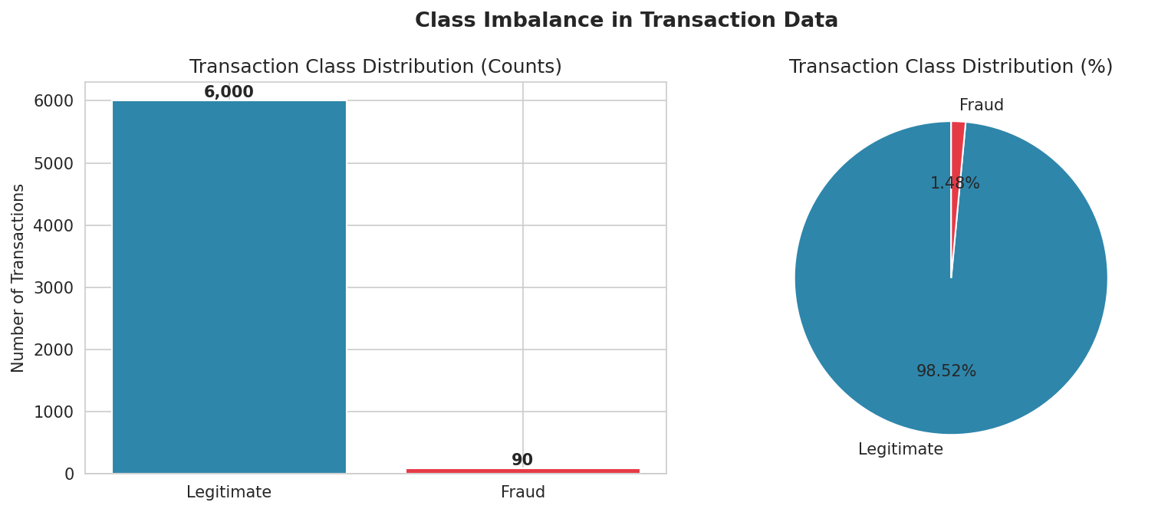

2.2 Transaction Amount Patterns
Fraudulent transactions have a lower median amount (12.54) than legitimate ones (47.62), consistent with small "card testing" charges used to validate stolen card details before a larger purchase is attempted. Fraud amounts also show a wider spread, driven by occasional large-value fraudulent transactions.
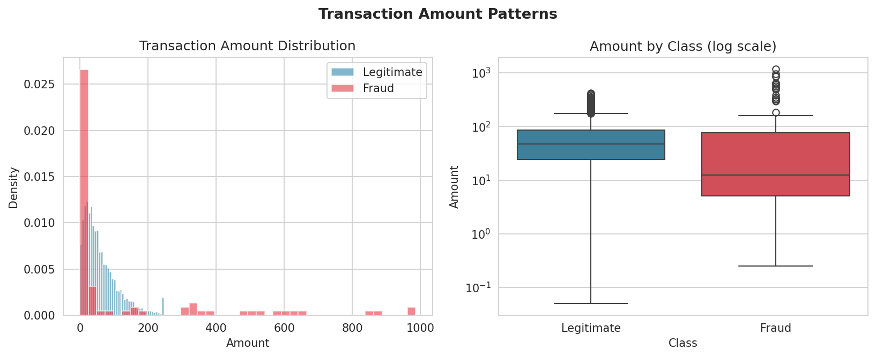

2.3 Timing Patterns
Fraudulent activity is not evenly distributed across the day. In this dataset, fraud incidence peaks around hour 18:00, which is a useful signal for time-aware risk scoring.
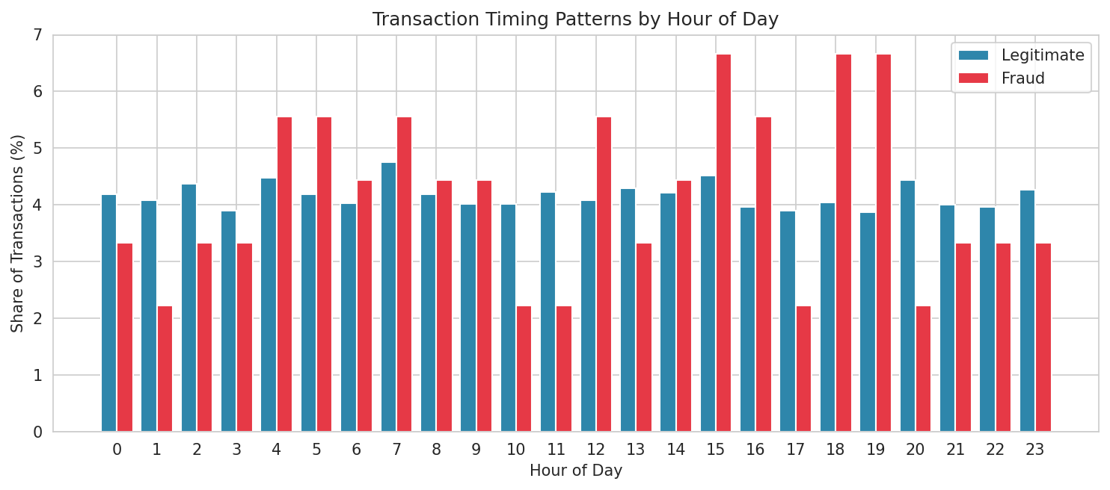

2.4 Feature Correlation
A subset of anonymized features shows meaningfully stronger correlation with the fraud label than others, which later informs feature importance in the trained model.
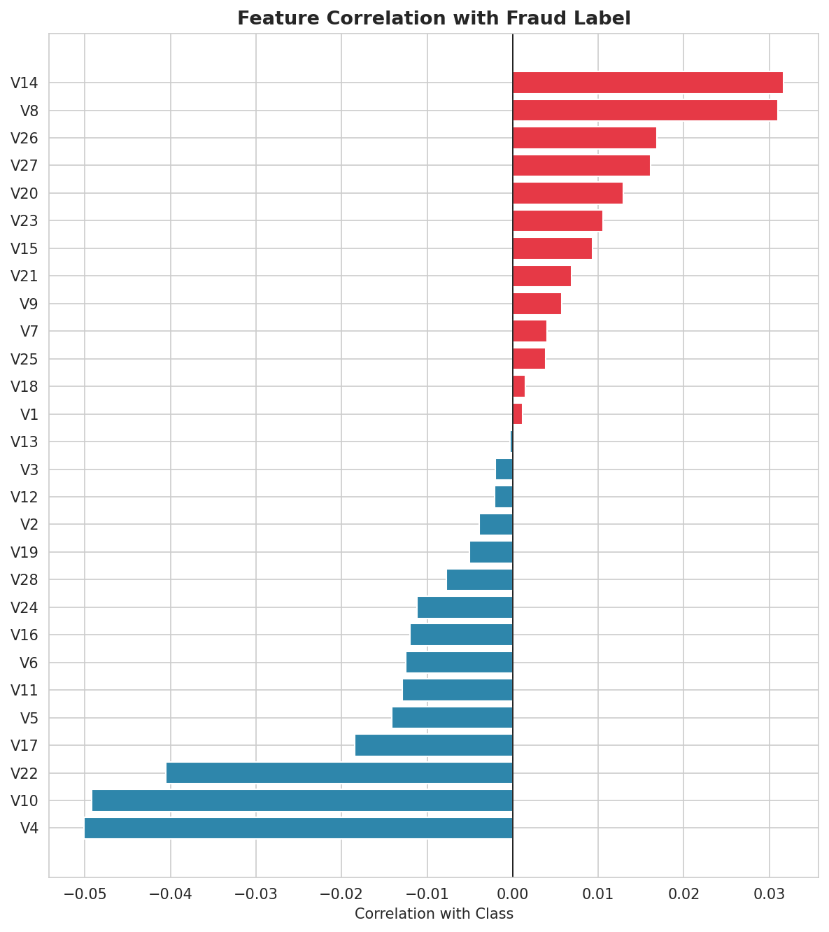

3. Model Development & Comparison
Three classification models were trained on a SMOTE-balanced training set and evaluated on a held-out test set that preserves the original class imbalance, to reflect real-world deployment conditions:
Model | Precision | Recall | F1-Score | ROC-AUC
Logistic Regression | 0.0686 | 0.6087 | 0.1233 | 0.7944
Random Forest | 0.4231 | 0.4783 | 0.449 | 0.9753
Gradient Boosting | 0.3125 | 0.6522 | 0.4225 | 0.9688

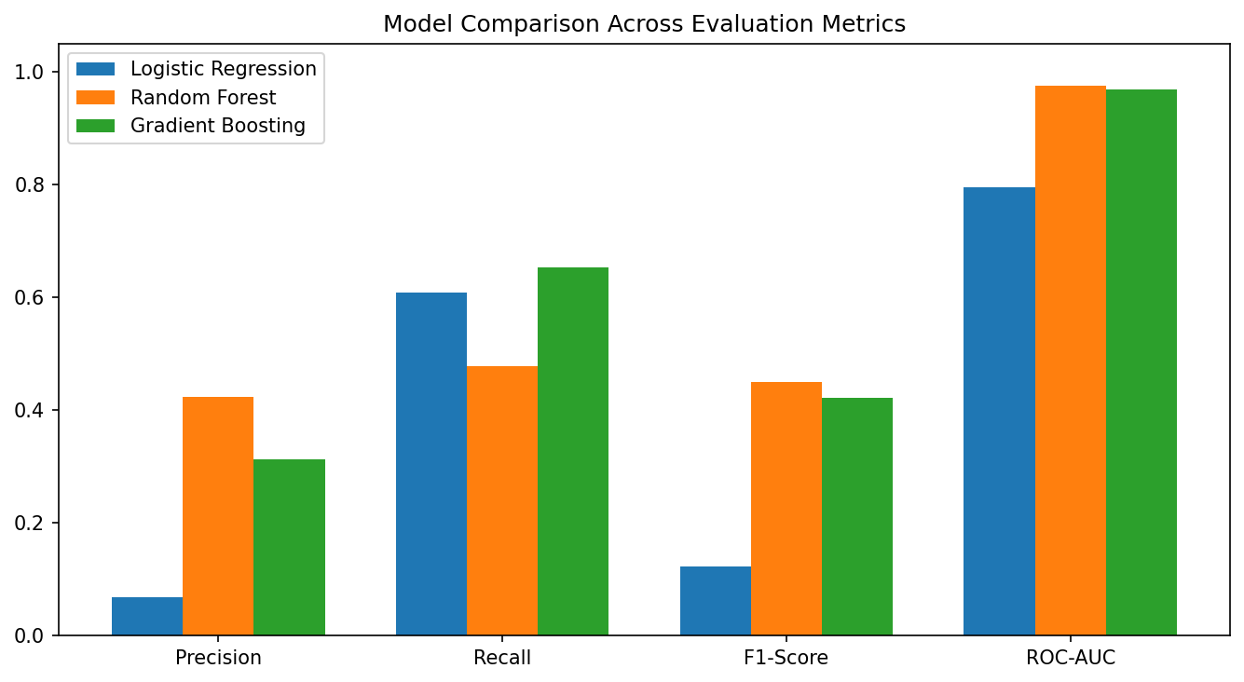

3.1 Selected Model
Random Forest was selected as the best-performing baseline and further tuned with GridSearchCV. The tuned configuration ({"max_depth":12,"n_estimators":100}) achieved the following results on the held-out test set:
Metric | Value
Precision | 0.6667
Recall | 0.5217
F1-Score | 0.5854
ROC-AUC | 0.9846

3.2 Confusion Matrix & ROC Curve
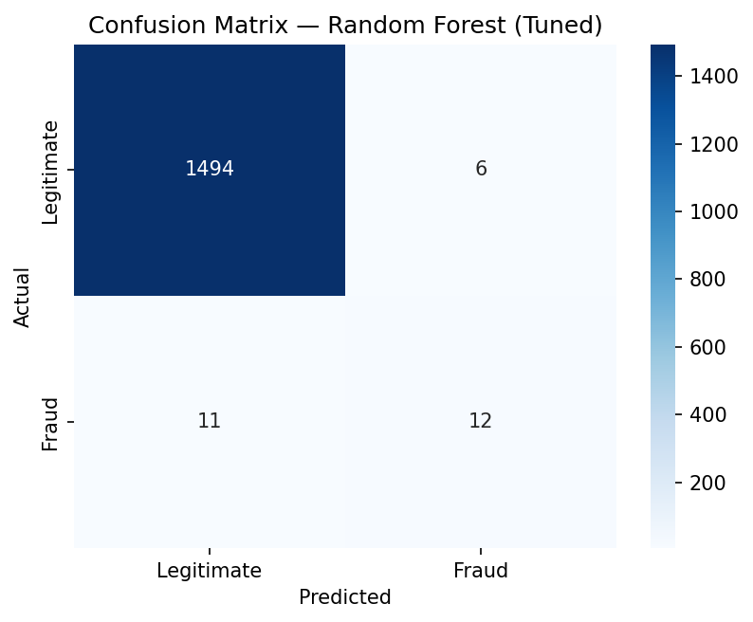
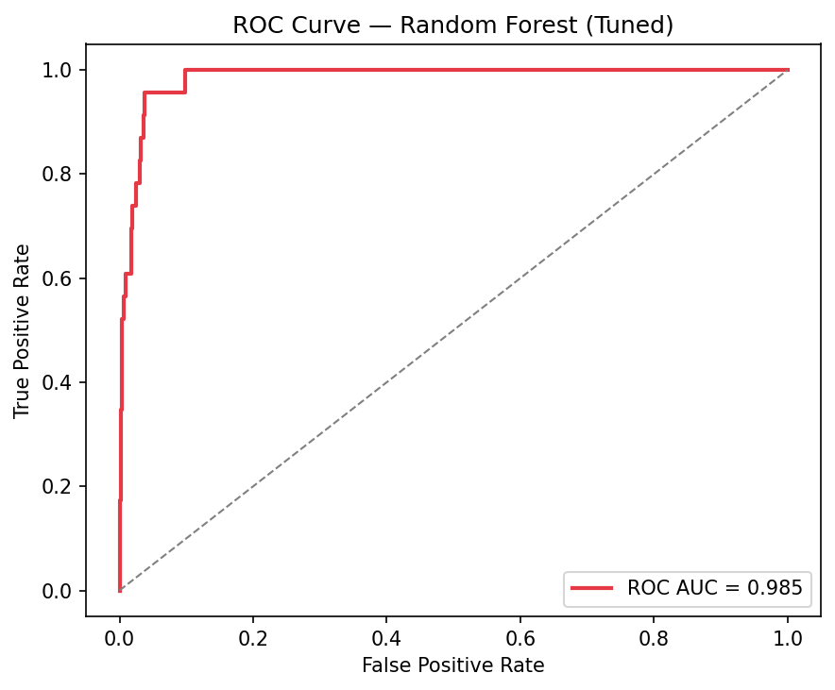

4. Fraud Pattern & Feature Importance Analysis
The chart below ranks features by their contribution to the model's fraud predictions.
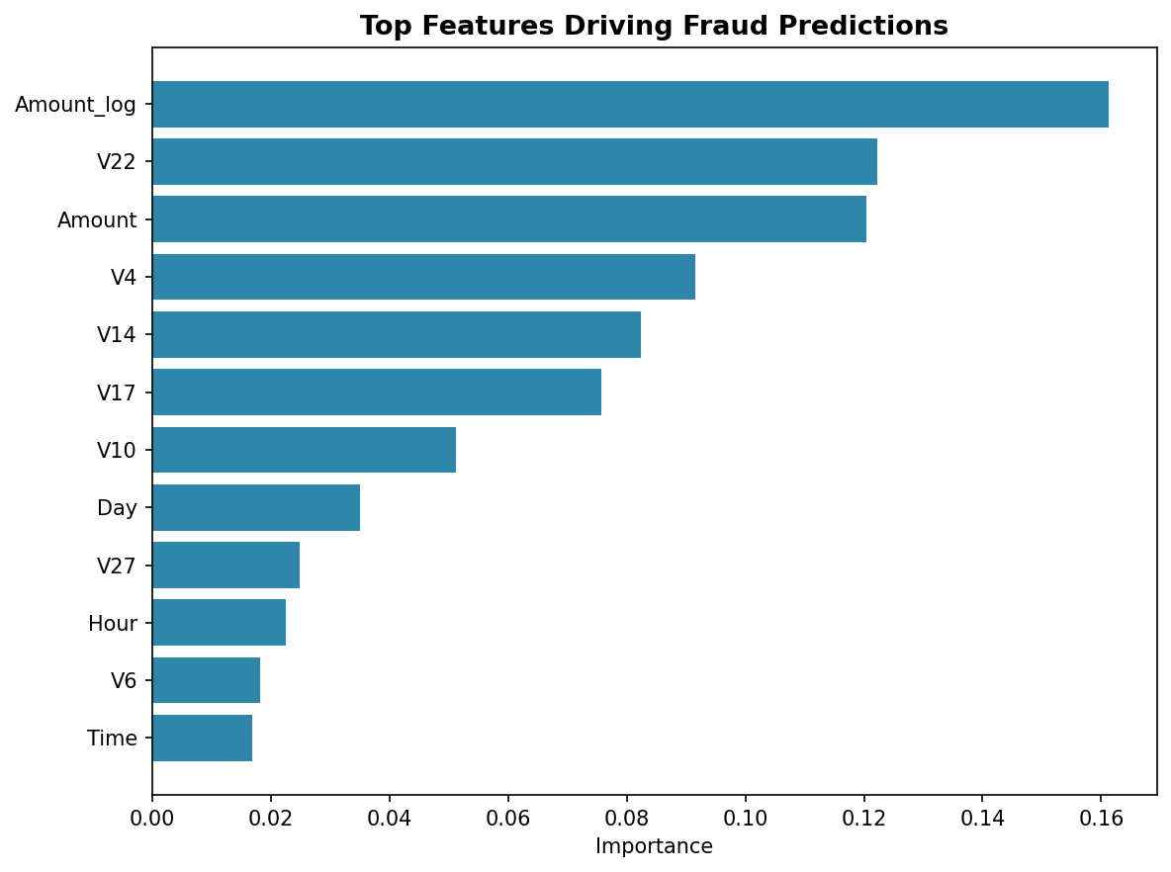

Top Contributing Features
Feature | Importance
Amount_log | 0.1613
V22 | 0.1223
Amount | 0.1203
V4 | 0.0915
V14 | 0.0824
V17 | 0.0757
V10 | 0.0512
Day | 0.0351

5. Business Insights & Recommendations

Key Findings
- Fraudulent transactions skew toward smaller amounts (median 12.54) than legitimate ones (median 47.62), a pattern consistent with card-testing behavior.
- Fraud incidence peaks around hour 18:00, suggesting time-of-day is a useful risk factor.
- A concentrated set of transaction features carries most of the predictive signal, supporting a lean, fast-scoring model suitable for near real-time screening.
- The tuned model reaches a recall of 0.5217 and precision of 0.6667 on the fraud class, catching a majority of fraud cases while keeping the false-positive volume manageable for manual review.

Recommendations
- Deploy the model as a first-pass screening layer ahead of manual fraud review, rather than a fully automated block/allow decision, given the cost asymmetry between missed fraud and false alarms.
- Apply additional scrutiny to low-value transactions occurring during peak fraud hours, since these combine two of the strongest observed risk signals.
- Track precision and recall on a rolling basis and retrain periodically on newly confirmed fraud cases, since fraud patterns evolve over time.
- Consider a cost-sensitive decision threshold rather than the default 0.5 cutoff, tuned to the organization's relative cost of false positives versus false negatives.

